# AMERICAN INTERNATIONAL UNIVERSITY BANGLADESH

Faculty of Engineering

# Laboratory Report Cover Sheet

***Students must complete all details except the faculty use part.***

Please submit all reports to your subject supervisor or the office of the concerned faculty.

Lab Title: **Study of Nyquist bit rate and Shannon capacity using MATLAB**

Experiment Number: **03** Due Date: **26 /02/2024** Semester: **Spring 2023-2024** Subject Code: **COE3103** Subject Name: **DATA COMMUNICATION** Section: **E** Course Instructor: **NOWSHIN ALAM** Degree Program: **B.Sc. CSE**

## Declaration and Statement of Authorship:

1. I/we hold a copy of this report, which can be produced if the original is lost/ damaged.
2. This report is my/our original work and no part of it has been copied from any other student’s work or from any other source except where due acknowledgement is made.
3. No part of this report has been written for me/us by any other person except where such collaboration has been authorized by the lecturer/teacher concerned and is clearly acknowledged in the report.
4. I/we have not previously submitted or currently submitting this work for any other course/unit.
5. This work may be reproduced, communicated, compared and archived for the purpose of detecting plagiarism.
6. I/we give permission for a copy of my/our marked work to be retained by the school for review and comparison, including review by external examiners.

## I/we understand that

1. Plagiarism is the presentation of the work, idea or creation of another person as though it is your own. It is a form of cheating and is a very serious academic offence that may lead to expulsion from the University. Plagiarized material can be drawn from, and presented in, written, graphic and visual form, including electronic data, and oral presentations. Plagiarism occurs when the origin of the material used is not appropriately cited.
2. Enabling plagiarism is the act of assisting or allowing another person to plagiarize or to copy your work.

|  |  |  |  |  |  |  |  |  |  |  |  |  |
| --- | --- | --- | --- | --- | --- | --- | --- | --- | --- | --- | --- | --- |
| Group Number (if applicable): 8 | | | Individual Submission | | |  | Group Submission | | |  |  |  |
|  | | | | | | | | | | |  |
| **No.** |  | **Student Name** | | **Student Number** |  |  | **Student Signature** |  | **Date** | |  |
| **Submitted by:** | | | | | | | | | | |  |
| **1** | | **KHUSHBU ALAM RAHI** | | **22-46947-1** | |  | | |  | |  |
| ***For faculty use only:*** | | | | **Total Marks: Marks Obtained:** | | | | | | |  |  |
| **Faculty comments** | | | | | | | | | | |  |
|  | | | | | | | | | |  |  |

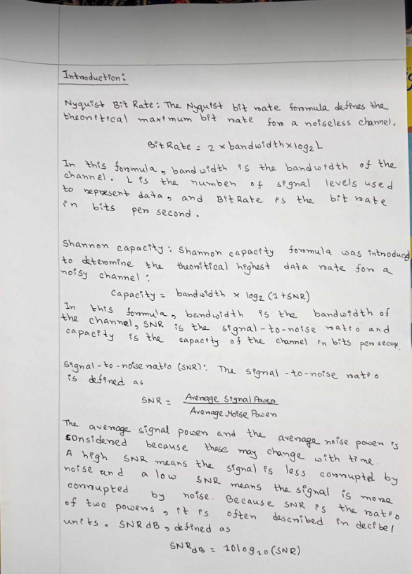

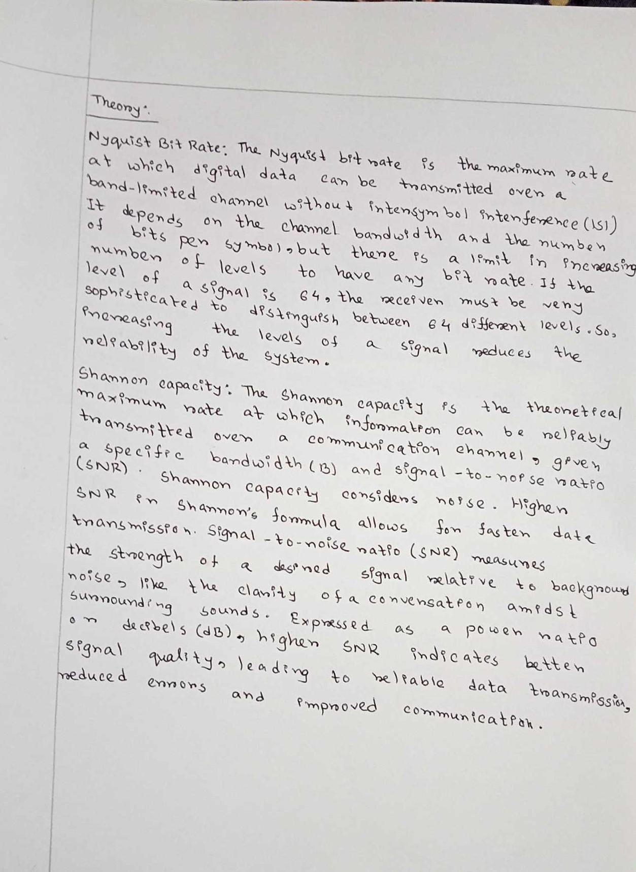

**Simulated Results:**

ID = AB-CDEFG-H

ID = 22-46947-1  
  
x = A1 sin(2π((C+D+H)*100)t ) + A2 cos(2π((D+E+H)*100)t) + s*randn(size(t));  
The values of the frequency are as follows: f1=(C+D+H)*100 and f2=(D+E+H)*100  
  
 (a)  
  
The value of the amplitudes were selected as follows: let *A*1 = (A+B+H), *A*2 = (B+C+H) and s = (C+D+H)/30   
  
**Code and Simulation:** (b)  
  
Calculating the SNR value of the composite signal reveals the **ratio of the original signal's strength to the added noise  
  
Code and Simulation:** Figure 1:Calculation SNR value of the composite signalFigure: Time vs Signal and Time vs Noisy Signal   
  
  
  
  
  
  
  
  
 (c)  
  
 Figure 2: Time vs Signal and Time vs Noisy Signal  
  
 (c)  
  
  
  
**Code and Simulation:**

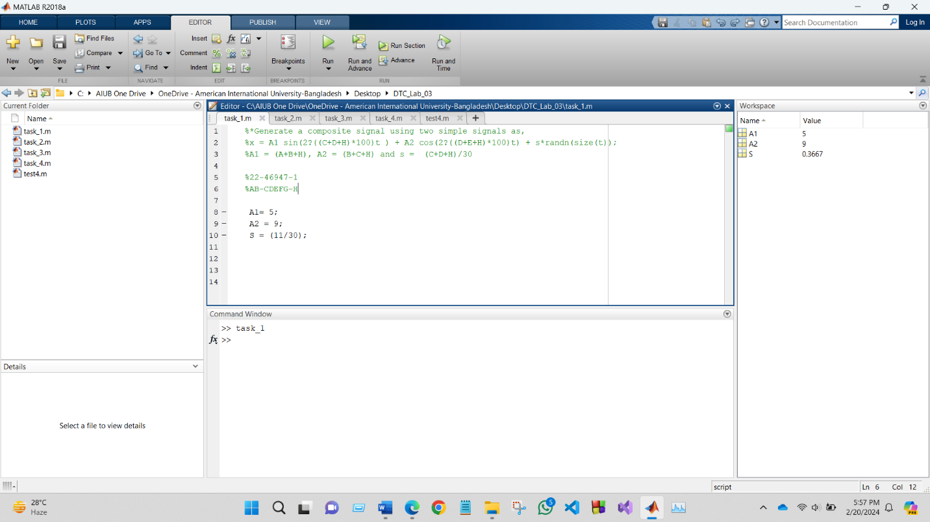

%22-46947-1

%AB-CDEFG-H

A1= 5;

A2 = 9;

S = (11/30);

close all;

clc;

%22-46947-1

%AB-CDEFG-H

A1= 5;

A2 = 9;

s = (11/30);

%Define number of samples to take

fs = 20000; % Sampling frequency

f1 = 1100; %Hz

f2 = 1600;

%Define signal

t = 0 :1/fs: 1-1/fs;

% powfund = A1^2/2 + A2^2/2

% % s = 0.1;

% varnoise = s^2;

x = A1*sin(2*pi*f1*t) + A2*sin(2*pi*f2*t) + s*randn(size(t));

%noise

signal = A1*sin(2*pi*f1*t) + A2*sin(2*pi*f2*t) ;

noise = s*randn(size(t));

%noisy signal

noisySignal = signal + noise;

SNR = snr(noisySignal) %Calculation of SNR using snr

% defSNR = 10*log10(powfund/varnoise)

subplot(211);

plot(t, signal)

title("time vs Signal")

xlabel("time")

ylabel("Signal")

axis([0 0.02 -15 15])

subplot(212);

plot(t, noisySignal)

title("time vs noisy signal")

xlabel("time")

ylabel("noisy signal")

axis([0 0.02 -15 15])

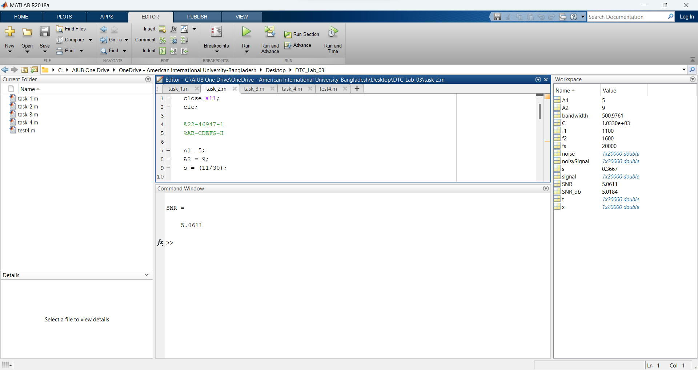



close all;

clc;

%22-46947-1

%AB-CDEFG-H

A1= 5;

A2 = 9;

s = (11/30);

%Define number of samples to take

fs = 20000; % Sampling frequency

f1 = 1100; %Hz

f2 = 1600;

%Define signal

t = 0 :1/fs: 1-1/fs;

% powfund = A1^2/2 + A2^2/2

% % s = 0.1;

% varnoise = s^2;

x = A1*sin(2*pi*f1*t) + A2*sin(2*pi*f2*t) + s*randn(size(t));

%noise

signal = A1*sin(2*pi*f1*t) + A2*sin(2*pi*f2*t) ;

noise = s*randn(size(t));

%noisy signal

noisySignal = signal + noise;

SNR_db = snr(noisySignal) %Calculation of SNR using snr

SNR=10^(SNR_db/10)

% defSNR = 10*log10(powfund/varnoise)

bandwidth = obw(x, fs)

C = bandwidth*log2(1+SNR)

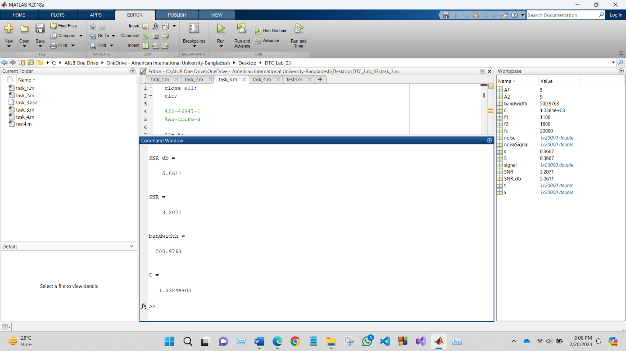

Figure 3: Calculation bandwidth of the signal and Maximum capacity, C of the channel

(d)  
  
  
   
**Code and Simulation:**  
  
 Figure 4: Calculation signal level, L

close all;

clc;

%22-46947-1

%AB-CDEFG-H

A1= 5;

A2 = 9;

s = (11/30);

%Define number of samples to take

fs = 20000; % Sampling frequency

f1 = 1100; %Hz

f2 = 1600;

%Define signal

t = 0 :1/fs: 1-1/fs;

% powfund = A1^2/2 + A2^2/2

% % s = 0.1;

% varnoise = s^2;

x = A1*sin(2*pi*f1*t) + A2*sin(2*pi*f2*t) + s*randn(size(t));

%noise

signal = A1*sin(2*pi*f1*t) + A2*sin(2*pi*f2*t) ;

noise = s*randn(size(t));

%noisy signal

noisySignal = signal + noise;

SNR_db = snr(noisySignal) %Calculation of SNR using snr

SNR=10^(SNR_db/10)

% defSNR = 10*log10(powfund/varnoise)

bandwidth = obw(x, fs)

C = bandwidth*log2(1+SNR)

N = 0.8 * C

y = N / (2 * bandwidth);

L = ceil(2^y)



